Newsletter November 2021

Staffing – Meet our wonderful Willows Team
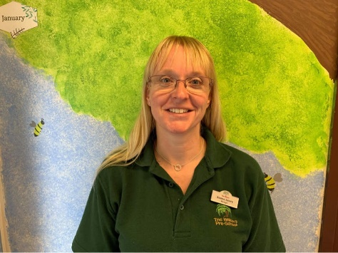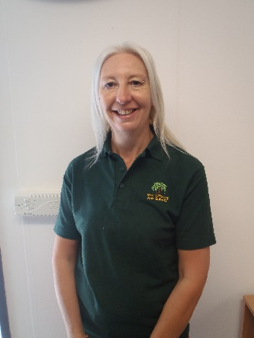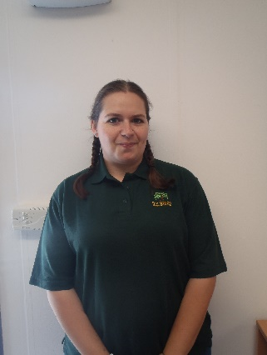
Gemma Julie Lou
Pre-school Manager Deputy Manager Senior Early Years Practitioner
Designated Safeguarding Lead Deputy Safeguarding Officer Behaviour Management
SENCO Deputy Health and Safety Officer
Health and Safety Officer

Tuesday, Thursday & Friday Monday, Wednesday Monday, Tuesday &
Wednesday from home & Friday all day. Thursday AM Thursday all day

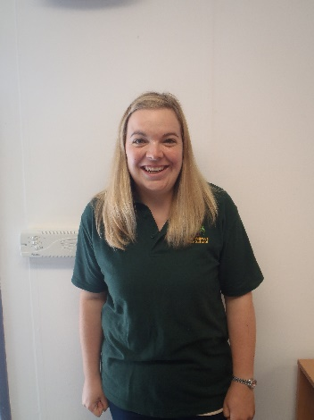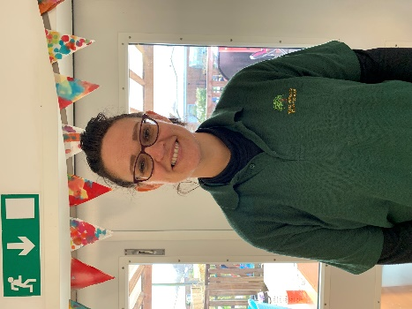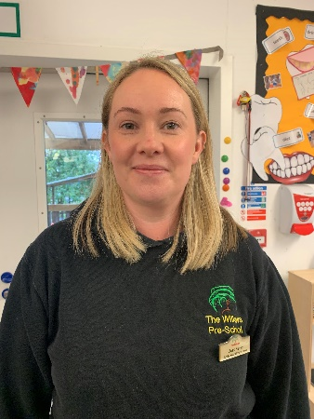
Lydia Diana Jess
Early Years Practitioner One-to-one support Early Years Practitioner

Tuesday, Wednesday & Friday’s Monday – Friday Monday and Thursday’s

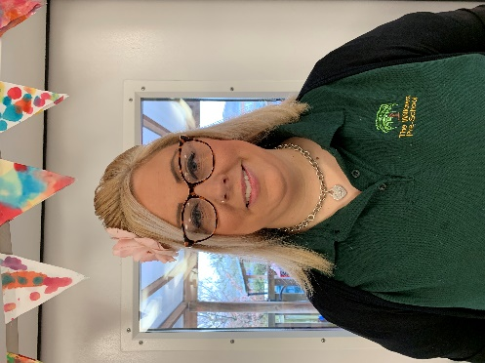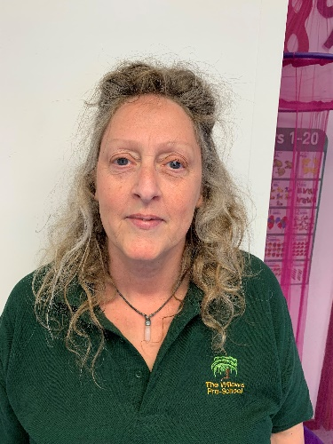
Kelly Liza Ali
Early Years Practitioner Early Years Practitioner Early Years Assistant

Wednesday and Friday’s Tuesday all day Bank Staff
Also Bank Staff when needed Committee member

Our committee – From September 2021 we have had several new parents join our committee. As most of you are aware, if we do not have a committee the Pre-School will not be able to open.

Below are the committee members. If you would like to join our committee, please email Lauren committeethewillows@gmail.com

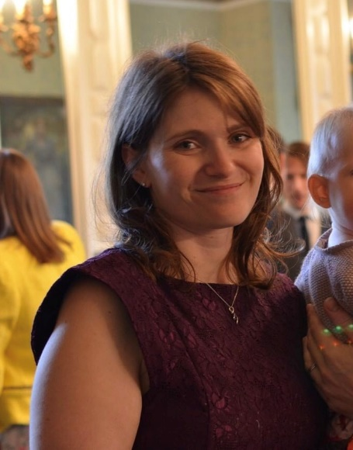
Lauren Aimi Beccy Helen
Chair Secretary Treasurer Committee member

The children have been having lots of fun since returning after the summer holiday. They have made friendships with peers, engaged in numerous learning activities with staff and participated in new experiences.

Firstly, we would like to say a very big thank you to all the families that took part in our colour scavenger hunt during the October half term. We raised an amazing £471.00.
We have some wonderful news, Freddie’s Dad’s workplace Medical Wire & Equipment in Corsham would like to support The Willows and have agreed to match our fundraising total resulting in us raising a staggering £942.00. We are extremely thankful and this will help go towards buying new bikes etc for the children. Once purchased we will upload the photos on our Facebook page.

Christmas

The Pre-School Christmas Parties will be taking place on Monday 13th December to Wednesday 15th December. We will be having a surprise visit from Father Christmas.

As a team we have decided to do our Christmas performance behind closed doors again this year. This was not an easy decision to make but due to COVID, we want to minimise the risk of spreading and contracting the virus.
We will be recording the performance the week commencing Monday 29th November. The recording will be uploaded to our Private Facebook page.

Lou, our amazing photographer will be taking photos of each child in their Christmas outfit for the performance These will be available to buy. More information to follow.

On Tuesday 14th December it is the schools Christmas Dinner Day. If you would like to order your child a Christmas dinner, please could you email by Friday 10th December. £2.00 cash payment will be needed. We are going to make this lunch a very social occasion. All staff will be having a lunch and there will be crackers etc.

Christmas Jumper Day is Friday 10th December. Your child is welcome to wear a Christmas jumper or top to Pre-School.

The staff have been busy making the Pre-School room all Christmassy for the children.

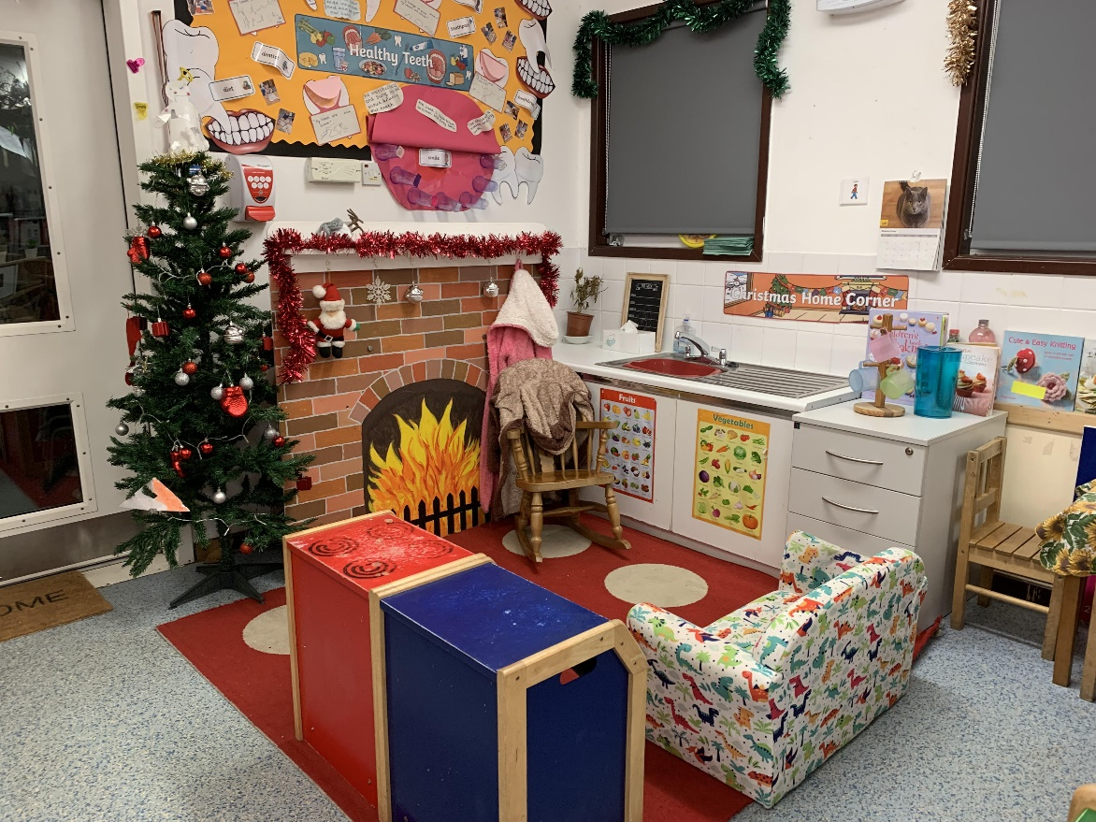

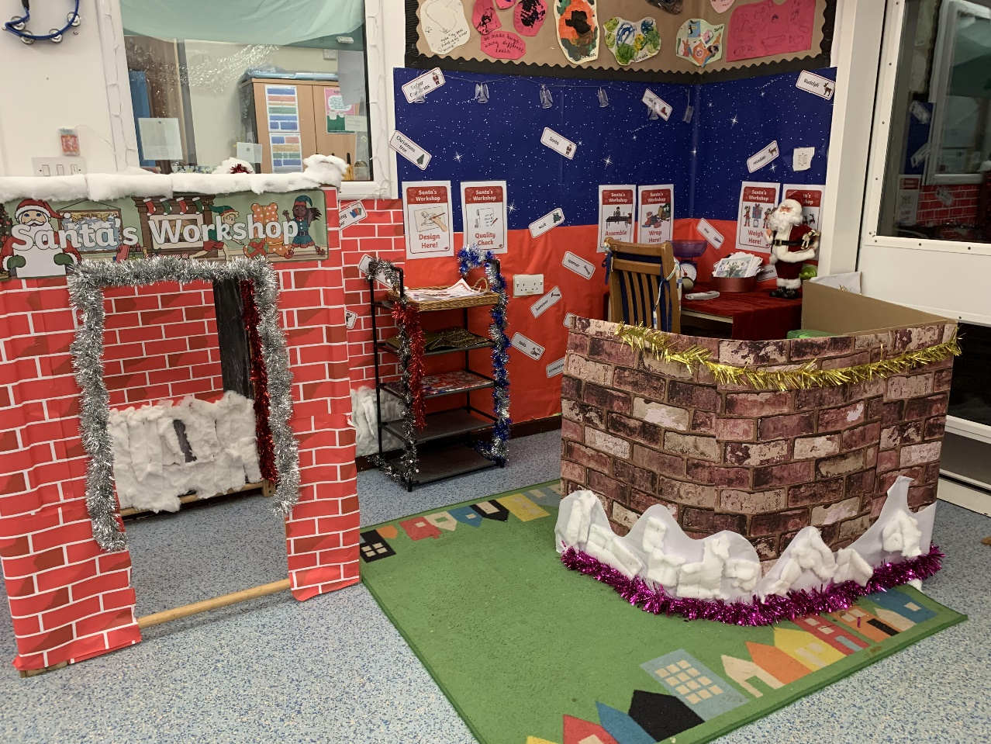

Polite reminders:
- Please do not park in the DROP OFF zone outside the school. This is only used for school parents to drop their child/ren off.
- Please could you ensure your child’s lunch box does not contain and items with nuts. This includes Nutella etc.
- As it is getting colder and we go outside each session, please could you ensure your child comes to Pre-School with a coat and hat. These need to be clearly labelled.
- Please could all parents and carers wear a facemask when dropping and collecting children at Pre-school. This is to prevent the spread of Covid.

Dates for your diary:

- Last day of term – Thursday 16th December 2021
- Staff Training day - Friday 17th December 2021
- First day back in the new year – Tuesday 4th January 2022

