Newsletter
November 2019

Click here to enter text.

We are pleased to announce and welcome our newly appointed Preschool Manager. Her name is Gemma Savery and she will be starting with us on Tuesday 10th December. Gemma has a number of years experience managing nurseries and is looking forward to the new challenge of managing our preschool, especially at this exciting time with the school merger due to take place. She will be attending our nativity and this will be another opportunity to talk to parents/carers and see the children perform.

This month the children have been learning about Remembrance and they made some beautiful poppies.
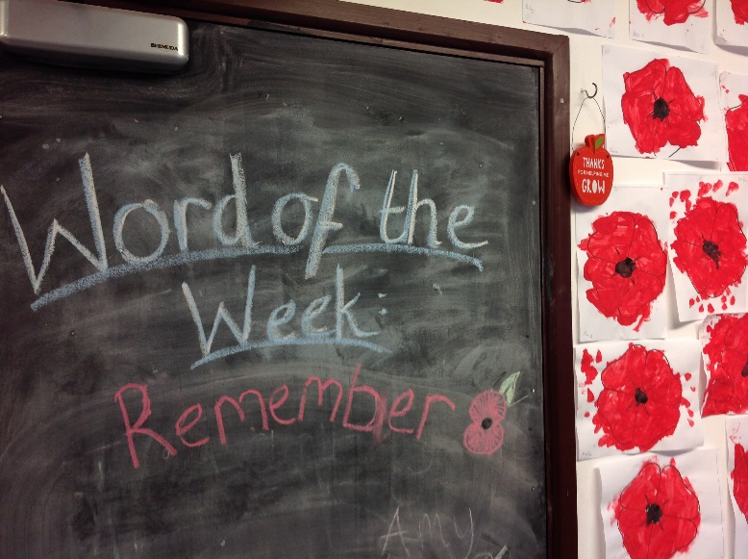
Scavenger Hunt. A massive thank you to all the children who participated in the Scavenger Hunt. The children collected some amazing items and we raised a huge amount of £463.50. We have two winners, Archie A for the most sponsorship money collected and our second winner, Sophia M for her beautiful nature collection. Prizes will be awarded in due course. Once again thank you all so much.

The children made some lovely Christmas decorations with the items collected from the hunt.
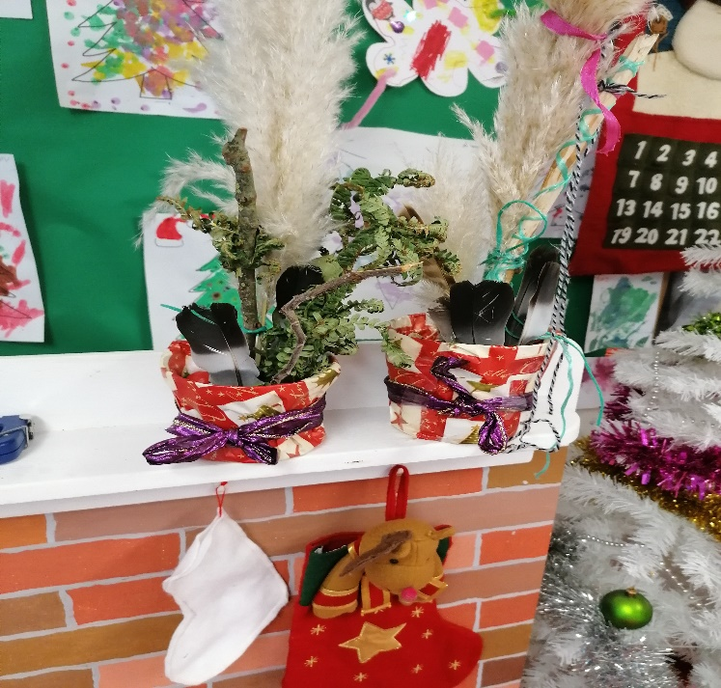
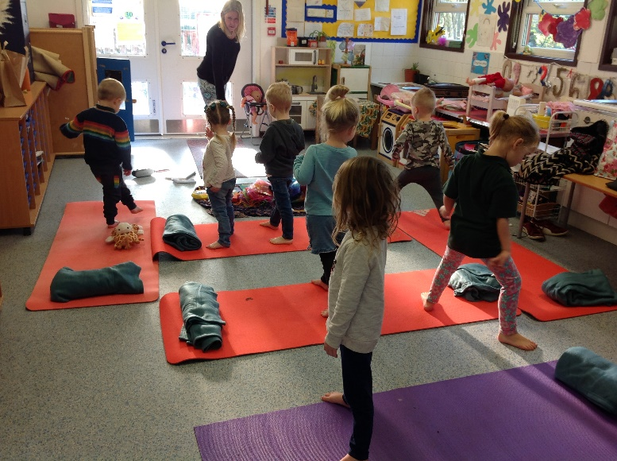
Yoga session. Debbie from Vibes came in for the morning and the children had a fun yoga session. Debbie specialises in Mental Health & Well Being in children.

Newsletter
Newsletter
Christmas Jumper Day will be on Friday 13th December and it would be lovely to see the children in their Christmas jumpers. We would like to include all children who attend on different days, so we are holding this event every day during w/c 9th December. This is in aid of Save the Children and would ask a donation of £1 please.

Nativity. Will be held on Monday 16th December at North Bradley Memorial Hall. Can children please be there at 1pm. The performance will start once all children are in their costumes. Christmas raffle/hamper donation box is now in the foyer.

Term & TD dates:
TD days – Fri 20th December – CLOSED
Mon 20th July 2020 – CLOSED
Tues 21st July 2020 – CLOSED
Wed 22nd July 2020 - CLOSED
End of term – Fri 20th December until Fri 3rd January 2020 inclusive. Return to preschool on Monday 6th January 2020

Lou has created a new closed Facebook group called “The Willows Preschool North Bradley”. Please join this page for up to-date information from the management team and committee.

Newsletter. In order to reduce paper and printing costs, we will no longer be printing a copy for each parent/carer. We will publish the newsletter on Facebook, our website http://www.thewillowspreschool.org.uk/ and display a copy on the notice board in the foyer. If you would like a copy e-mailed or printed, then please ask a member of staff.

