Newsletter
February 2020

Click here to enter text.

This month we have been learning about the Chinese New Year. We have made dragon masks, Chinese banners 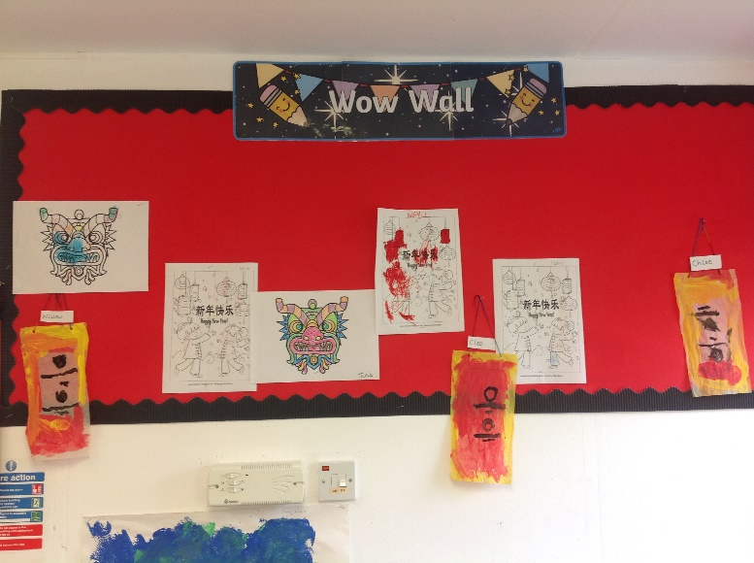
and tasted some yummy Chinese food.
__________________________________________
This week we will be handing out boxes of Smarties and hope you be able to take part in the Smartie Challenge to help raise funds for the Preschool.
__________________________________________
We are looking for donations from parents/guardians for any old pots and pans for the children to use in the sensory garden.

We are also looking for volunteers to come into Preschool to help out. Whether it be to read a story, share a hobby, crafting, play with the children or do some gardening. Your help would be very much appreciated. Please speak to a member of staff if you are available to assist.
__________________________________________
Valentine’s Day
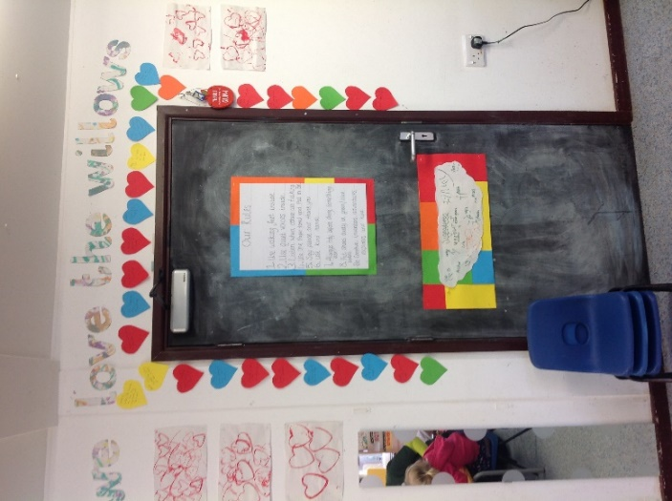
Learning all about love and Our Rules
_____________________________________
A big thank you to Jade Welch for kindly donating to the preschool various items of kitchen equipment.
__________________________________________
Reminders:
*Please ensure you use the school’s one way system when dropping your children off at Preschool. Come into Church Lane from Southwick Road and leave by Westbury Road. Please do not park in the DROP OFF zone. This is for dropping off only.
*Hot lunches are available every day at a cost of £2.30 each.
*Please remember to sign your child in and out for each session. This is imperative for evacuation purposes.
*It is also important that all your child’s clothes/belongings are all named.
*To report absences please email staffwillows@googlemail.com or telephone 01225 769489. Please do not report on Facebook.
*We are no longer charging for snacks and are asking for a donation of £5 per term. We have a collection box for this and do ask that you contribute when possible.
*In order to reduce paper and printing costs, we will no longer be printing a copy of the newsletter. We will publish this on Facebook (The Willows Preschool North Bradley), our website http://www.thewillowspreschool.org.uk and display a copy on the notice board in the foyer. If you would like a copy e-mailed or printed, then please ask a member of staff.

*Please remember not to add any peanut products in your child’s lunchbox, eg peanut butter sandwich. There is a child in the preschool with a peanut allergy.
*We close for half-term at 3pm this Friday 14th February and return on Monday 24th February.
Dates for your diary:
*February Half Term – Smarties tube Valentines’s fundraisher challenge.
*Tuesday 31st March at 2pm – Easter event with bonnet parade.
*Thursday 23rd April at 5.30pm – Bug Night with Kris from Tropical Discoveries.
*Wednesday 10th June at 9.30am – Sports Day.
*Saturday 20th June – Village fete with a Willows stall.
*Friday 3rd July between 5-8pm – Summer BBQ event.

Happy Half Term holiday.

